|  |  |
| --- | --- |
| **Architetture dei Sistemi**  **di Elaborazione** | Delivery date:  Friday 23th December 2022 |
| **Laboratory**  **10** | Expected delivery of lab_10.zip must include:   * zipped project folder of exercise 1 and exercise 2. * this lab track completed and converted to pdf format. |

**Exercise 1)** Starting from the Exercise 1 of LAB 9, enhance the system on the LANDTIGER board in order to handle the bouncing and debouncing effects of the buttons.

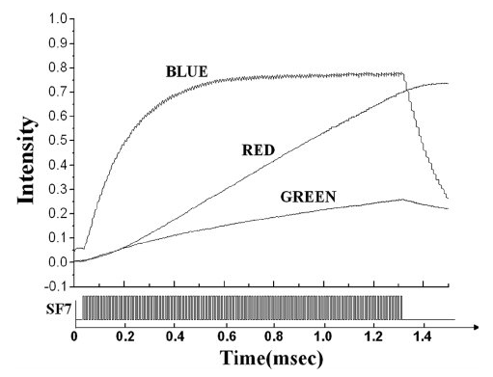

**Exercise 2)** Implement a system on the LANDTIGER board that can tune the brightness of an LED by making use of TIMERS. Dimming a LED is done by appropriately turning it ON and OFF. Usually, the maximum brightness (100% brightness) is achieved when it is ON for at least a period T period. Such T time value can be often found in the LED datasheet (when available). Please see an example, where also blue and green LEDs are considered, which shows a different behavior (non-linear).

For LANDTIGER red LEDs, the time to saturate should be in the order of few milliseconds; during this time the brightness increases almost linearly from no light to the maximum luminescence. Therefore, to achieve a 50% brightness, for instance, the LED would have to be ON half of the time in each T period (as shown in the Figure below).

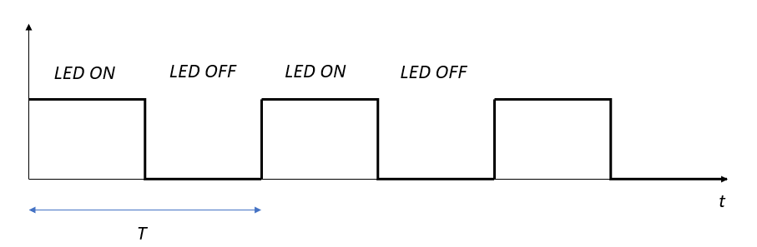

To solve the exercise, select one of the available LEDs, and use two Match Registers (MR0 and MR1) of TIMER 2 to synchronize the two phases. Specifically, it is necessary to set the two Match Registers so that, when TIMER 2 reaches MR0 the LED turns OFF; when the timer reaches the value held in MR1, the LED must light up. You are requested to experimentally determine the time interval T needed to reach the maximum brightness.

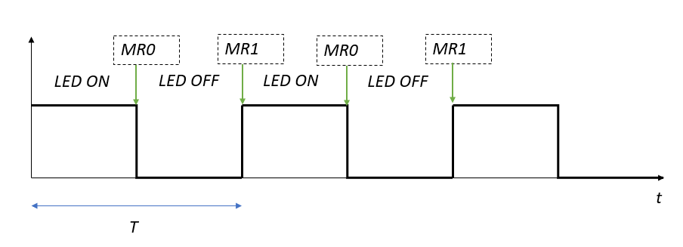

Extend the function the LED library to set up the values of MR0 and MR1 of TIMER 2 and to control the brightness of the LED. Fill in the table below with the **match register values** needed to achieve the required brightness.

|  |  |  |  |  |
| --- | --- | --- | --- | --- |
| **Brightness [%]** | **MR0** | **MR1** | **Time ON** | **Time OFF** |
| 25 | **0x00001D4C** | **0x00007530** | **0.3 ms** | **0.9 ms** |
| 50 | **0x00003A98** | **0x00007530** | **0.6 ms** | **0.6 ms** |
| 75 | **0x000057E4** | **0x00007530** | **0.9 ms** | **0.3 ms** |
| 100 | **0x00007531** | **0x00007530** | **1.2 ms** | **0 ms** |

NOTE:

1. To use TIMER2 functionalities, you must extend the available libraries and create the appropriate functions.
2. To determine the brightness of a LED is quite difficult and require expensive machineries (as shown below). We suggest you perform just a visual comparison with a setup where a LED modulated while another is always on.
3. Among the challenges of brightness modulation, try to avoid the flickering effect due to excessive period with very low percentage duty cycle (the LED looks to blink).

